Tech Trial Technical Document
Assignment documentation

2015
Jalal Uddin

10/11/2015

Table of Contents
Used Technologies: 1
Used Design Patterns: 2
Component Diagram: 2
Sequence Diagrams (Please zoom in to view properly): 3
Stock Price API Web Service Method 3
DashboardController GridDataForSymbols Action 4
DashboardController GridDataForStockPrices Action 5
DashboardController AddStockSymbol Action 6
DashboardController DeleteStockSymbol 7
Security method for Web service API: 8

Used Technologies:
- Entity Framework (Code First)
- JQuery
- Datatables
- Moq
- Ninject
- Visual Studio Unit Tests
- Visual Studio Modeling
- Asp.net MVC
- C#
- Sql Server 2014 (Standard edition)
- Visual Studio 2013 Ultimate edition
- Linq
- Dynamic Linq
- Log4net

Used Design Patterns:
- Singleton pattern
- Factory pattern
- Unit of work pattern
- Repository pattern
- Dependency Injection (IoC)

Component Diagram:
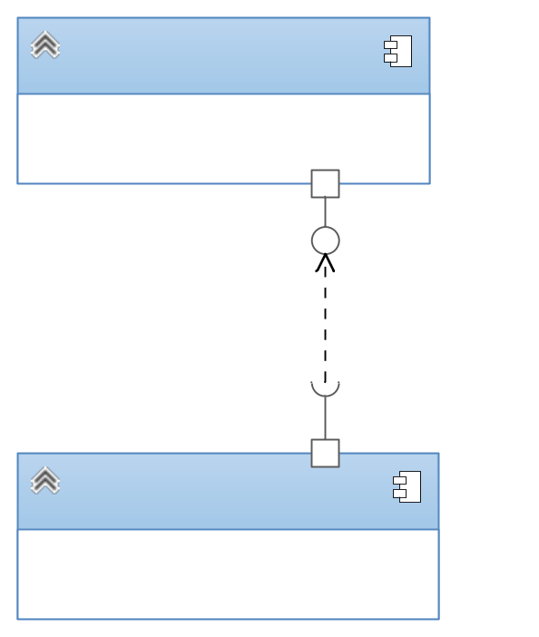

Sequence Diagrams (Please zoom in to view properly):
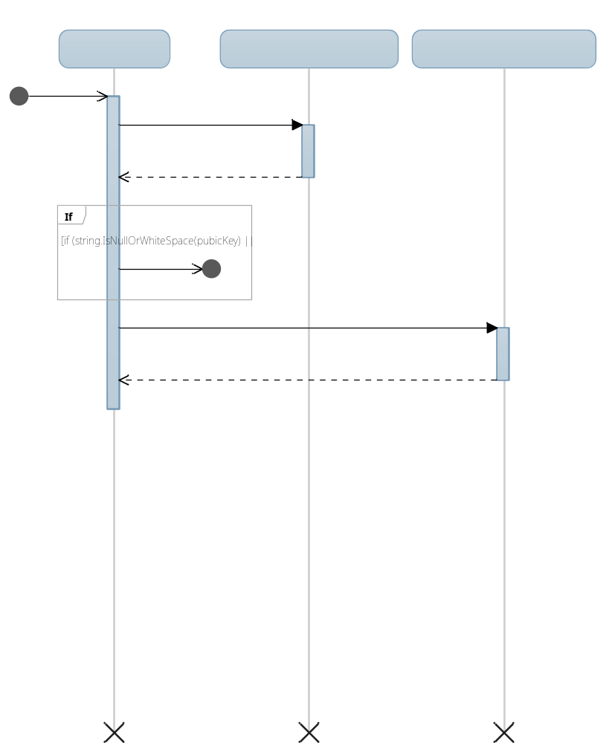

Stock Price API Web Service Method


DashboardController GridDataForSymbols Action



DashboardController GridDataForStockPrices Action


DashboardController AddStockSymbol Action

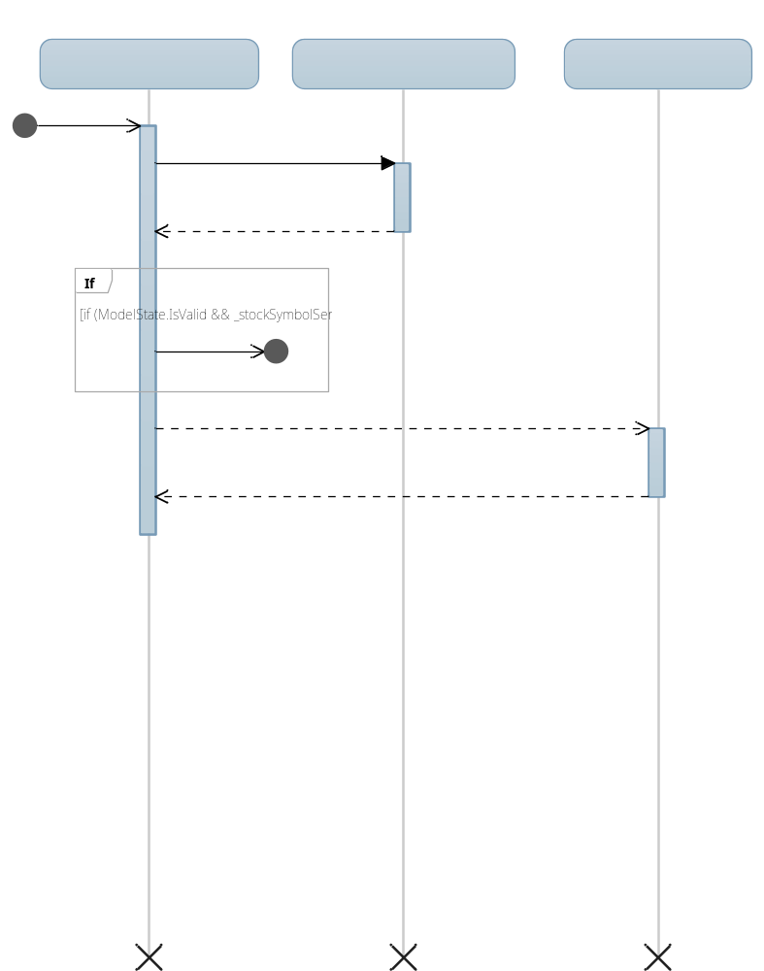

DashboardController DeleteStockSymbol

Security method for Web service API:
I have applied the security method that Amazon Web Services (AWS) applies for their API. The reason for choosing this method is, it is very easy to implement, simple to understand and very effective and efficient.
There are other methods such as OAuth, but these are complicated to implement and understand compared to the approach that AWS applies.
The method can be explained in following steps:
- There will be a set of public key and private key for each client.
- The Web Service API and client will know both of the keys.
- When client app needs to make request, it will create a serialized string for the payload data.
- Then a hash will be computed using the private key for the payload.
- Then client will send the public key, the computed hash and the actual payload to the API web service.
- Web service will use the public key to retrieve the private key from its own database.
- The web service will apply the same process to compute the hash on its own
- If the hash in the request and the hash that web service computed matches then the request came from an authentic source and thus we process the request otherwise we ignore the request.

